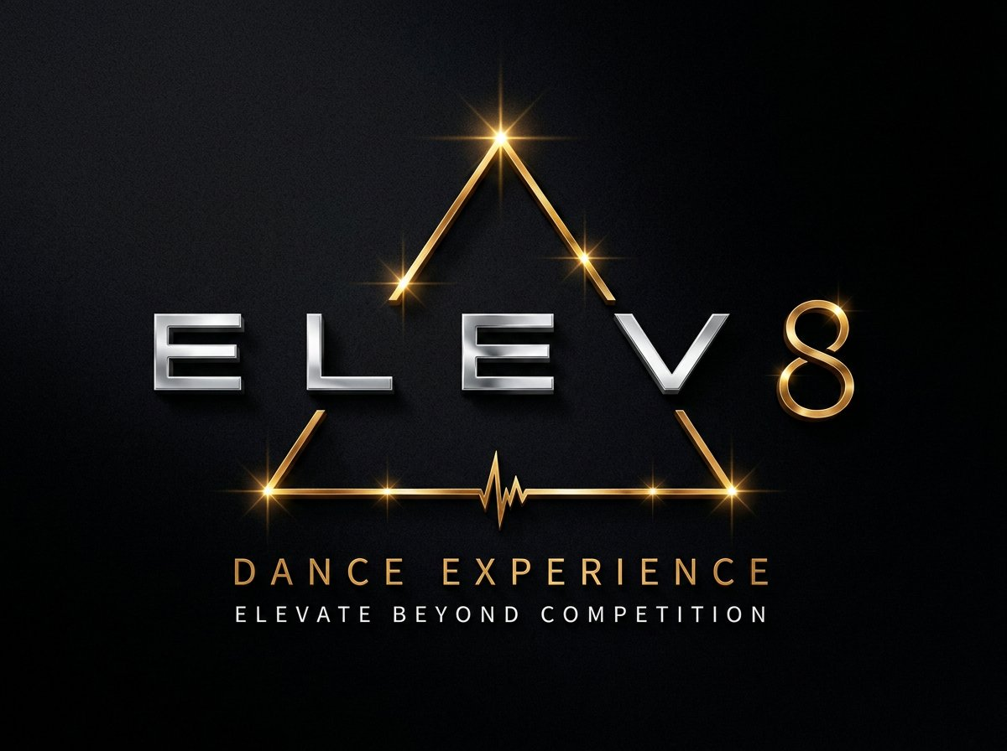 | OFFICIAL 2027 DOCUMENTATION  ELEV8 DANCE EXPERIENCE  Rules & Regulations  Dance Competition & Guidelines

Important Notice
Please read all rules and regulations carefully. It is the responsibility of each studio to ensure compliance with all policies outlined below. Failure to comply may result in score deductions and/or disqualification.

Questions? Contact us at info@elev8-experience.com

GENERAL RULES & INFORMATION
Registration Deadlines
Early Bird Pricing must be paid in full by December 17th, 2026. All entries must be submitted in full by Friday, January 8th, 2027. A 50% deposit of the registration balance is due by January 8th, 2027. Remaining balances are due by March 8th, 2027.

- Space is limited — studios are accepted on a first come, first served basis.
- The ELEV8 DANCE EXPERIENCE Event Fee is mandatory for all participating dancers. Event fee covers admission credentials, adjudication services, and participation in event activities.
- A studio representative must be present to collect awards during awards sessions or before the conclusion of the event. Awards will not be shipped.
- ELEV8-EXPERIENCE INC is not responsible for lost, stolen, or unattended items.
- Competition media will remain available for download for 1 year following the event through the ELEV8 app.
- Any schedule changes made after the finalized schedule has been released are subject to a $10 fee per change.

ELEV8 DANCE EXPERIENCE Has the Right To
- Cancel an event due to unforeseen circumstances
- Change event dates, format, or location
- Add additional competition days if necessary
- Limit, reject, correct, or refuse registrations at its discretion

HOUSE RULES
- Photography and videography of performances are strictly prohibited. ELEV8 team members reserve the right to request deletion of unauthorized photos or videos.
- Official event photos and videos will be available for download following the event.
- All judging decisions are final and non-negotiable.
- Harassment, disrespectful conduct, or unruly behaviour will not be tolerated and may result in disqualification and removal from the premises.
- Parents are not permitted backstage during the competition.
- Any concerns or issues must be addressed by studio owners or teachers directly through: info@elev8-experience.com

SEATING
- Teachers and Studio owners will receive priority reserved seating throughout the competition.
- General audience seating is available on a first-arrived, first-seated basis.
Venue Capacity
We make every effort to ensure adequate seating for all guests; however, please be aware that certain venues have limited capacity. Once maximum occupancy has been reached, entry may be managed at the discretion of venue management and/or ELEV8 staff in compliance with Safety and Fire Code regulations.

CLASSIFICATIONS

Novice  - 1–3 years of dance experience with an affiliated dance studio, whether recreational or competitive level. | Pre-Competitive  - 6 hours of training or less per week (including choreography).

Competitive  - More than 6 hours of training per week. | High School  - High school dance team.

Classification Threshold
50% or more of dancers must meet the classification requirements for the routine to qualify in that division.

INDEPENDENT ENTRIES
Independent entries are welcome; however, all dancers must be currently training and affiliated with a recognized dance studio. Studio affiliation must be disclosed at the time of registration.

AGE DIVISIONS
How Ages Are Calculated
Ages are calculated as of December 31st by averaging the ages of all performers and dropping decimals.

DIVISION | AGE RANGE
Petite | Ages 4–6
Mini | Ages 7–9
Junior | Ages 10–12
Intermediate | Ages 13–14
Senior | Ages 15–18
Adult | Ages 19 & older

Adult Division Rules
- Adults may not compete in younger divisions, except in Productions.
- Any routine containing a dancer aged 19+ will automatically compete in the Adult division.

Adult Eligibility
Adult routines (excluding Productions) are not eligible for: Top Studio Awards or The ELEV8 ULTIMATE DANCE BATTLE.

ENTRY TYPES

ENTRY TYPE | DANCER COUNT
Solo | 1 dancer
Duet | 2 dancers
Trio | 3 dancers
Small Group | 4–9 dancers
Small Group Extended ★ | 4–9 dancers
Large Group | 10–17 dancers
Large Group Extended ★ | 10–17 dancers
Line | 18+ dancers
Line Extended ★ | 18+ dancers
Production | Unlimited dancers

★ Extended Time entries carry an additional fee. Production routines must be between 6–11 minutes. Categories are determined by the number of dancers on stage, including last-minute changes.

TIME LIMITS
ENTRY TYPE | TIME LIMIT
Solos / Duets / Trios | 3 minutes
Small Groups | 3 minutes
Large Groups | 4 minutes
Line | 5:59 minutes
Productions | 6–11 minutes
Small Group Extended Time ★ | 3:30–7:00 minutes
Large Group Extended Time ★ | 4:30–7:00 minutes
Line Extended Time ★ | 6:00–7:00 minutes

★ Additional fees apply to all extended-time routines.

- Time limits include entrances and exits.
- Routines exceeding time limits by more than 30 seconds may incur additional fees and category changes.
- All music must be submitted electronically by the designated deadline and must comply with routine time limits.

DISCIPLINE
ELEV8 Dance Experience welcomes the following dance disciplines. Acro allowances vary by style, so please review the table below when planning choreography and styling for each routine.
STYLE | DESCRIPTION | ACRO TRICKS
Ballet | Classical ballet technique. Ballet shoes required. No acro tricks or pointe shoes. | None
Pointe | Ballet technique performed in pointe shoes. | None
Jazz | Traditional jazz technique and performance. | Max 3
Lyrical | Fusion of ballet and jazz focusing on emotional storytelling. | None
Contemporary | Combination of lyrical, modern, and jazz movement vocabulary. | Max 3
Tap | Rhythmic footwork. Pre-recorded tap sounds prohibited. | None
Musical Theatre | Dance performance with lip-syncing permitted. | Max 3
Song & Dance | Live singing with dance choreography. One headset mic for soloists only. | Max 3
Acro | Combination of dance and acrobatic/gymnastics technique. | Unlimited
Hip Hop | Street-style movement vocabulary. Acrobatics and breakdancing permitted. | Unlimited
Open | Combination of dance styles. Up to 50% may wear tap or pointe shoes. | Max 3
Production | Theme or storyline-based. Max 5-minute setup time. | Unlimited

COMPETITION RULES
- Studio owners and teachers must pick up their welcome package upon arrival. Please confirm the number of persons upon registration.
- Dancers must be ready to perform at least 60 minutes prior to their scheduled time.
- All routines must report to the backstage stage manager 4 numbers before they are scheduled to perform.
- Routines must perform in scheduled order unless approved by an ELEV8 DANCE EXPERIENCE Director.
- Routines performing outside their assigned session are ineligible for placements or top awards, unless approved due to medical emergency.
- Dancers may not compete against themselves in the same category and style.
- Soloists entering two routines in the same style must compete one age division higher.
- Groups may compete in the same category if at least 50% of dancers differ.
- Second performance attempts are permitted only if time allows.
- Re-performances receive adjudication only and are ineligible for standings or overall awards unless caused by music or costume malfunction.
- Routines containing inappropriate or suggestive material may be disqualified.
- Baby powder, paint, glitter, or any substances that leave debris or damage the stage are prohibited.
- Studios are responsible for any damage to dressing rooms or venue property.
- Judges' scoresheets will be emailed to studio directors after the event. All critiques will be provided in video format.

AWARDS
Awards / Scholarship & CA$H Prizes
At ELEV8 Dance Experience, we've reimagined what recognition can be and celebrate the very heart of dance — the stories, the artistry, the connection, the courage, and the moments that stay with you long after the curtain falls. Unique, meaningful, and designed with purpose, these are not your typical awards and unlike anything you've experienced before. At ELEV8 we honour the qualities that make dance truly unforgettable and can't wait to share this with you.

- Any monetary awards or CASH prizes will be given to the studio director, or to a teacher / studio representative following the competition by cheque. It is at the studio director's discretion how monetary and/or CASH prizes are distributed within the studio in accordance with studio policies.
- ELEV8 DANCE EXPERIENCE Directors have the right to adjust monetary prize winnings based on the size of the competition.
- Adult category participants are applicable for feedback and category placement only. Dancers in the Adult Category do not qualify for Overall Awards.

Final Decisions
All decisions made by the adjudicators or ELEV8 DANCE EXPERIENCE Directors are final.

PROPS
- All props must be declared prior to schedule finalization.
- Props may only be placed backstage during adjudication before the upcoming session.
- Maximum prop height is 10'6", unless venue limitations permit otherwise.
- Individuals used solely as props may not actively participate in the routine unless registered as performers.
- Productions requiring large props or special setup should contact ELEV8 DANCE EXPERIENCE in advance.

COPYRIGHT & CHOREOGRAPHY
Protected by Copyright  - An entire routine as a finished piece, including its overall artistic composition.  - The specific sequence of movement created for a routine, paired with its chosen music and staging. | Not Protected by Copyright  - Broad themes, styles, or creative ideas.  - Single steps or movements taken on their own, outside of a larger sequence.  - Shared use of costuming, music tracks, props, set pieces, or staging formations.

- Routines may be disqualified if found to have copied another choreographed work.
- Modified choreography is considered a new interpretation and not plagiarism.
- Ballet and Pointe Variations are exempt from plagiarism rules.

FINAL NOTES

Binding Agreement
All judging decisions are final. ELEV8 DANCE EXPERIENCE reserves the right to interpret and enforce all rules at its discretion. Participation in the event indicates acceptance of all rules and regulations listed above.

Questions? Contact us at info@elev8-experience.com
© 2027 ELEV8-EXPERIENCE INC. — All Rights Reserved.

